Amazon Basin Project - Implementation of the Strategic Action Programme (SAP) to ensure the integrated and sustainable management of transboundary water resources in the Amazon River Basin, considering climate variability and change

TERMS OF REFERENCE

HIRING OF A TECHNICAL ASSISTANT CONSULTANCY IN SUPPORT OF THE IMPLEMENTATION OF THE INTEGRATED IWRM PLATFORM IN THE CONTEXT OF THE PROJECT: IMPLEMENTATION OF THE STRATEGIC ACTION PROGRAMME TO ENSURE THE INTEGRATED AN SUSTAINABLE MANAGEMENT OF TRANSBOUNDARY WATER RESOURCES OF THE AMAZON RIVER CONSIDERING CLIMATE VARIABILITY AND CHANGE

Financing Agency: Global Environment Facility (GEF)
Implementing Agency: UN Environment Programme
Executing Agency: Amazon Cooperation Treaty Organization – ACTO
Project Duration: 6 years

Agencia Financiadora: Fondo para el Medio Ambiente Mundial (FMAM)
Agencia Implementadora: ONU Medio Ambiente
Agencia Ejecutora: Organización del Tratado de Cooperación Amazónica –OTCA
Duración del Proyecto: 4 años

Agencia Financiadora: Fondo para el Medio Ambiente Mundial (FMAM)
Agencia Implementadora: ONU Medio Ambiente
Agencia Ejecutora: Organización del Tratado de Cooperación Amazónica –OTCA
Duración del Proyecto: 4 años

ACTO - UNEP - GEF
Brasília, 2026

Background
The Amazon Basin faces numerous challenges for Integrated Water Resources Management (IWRM), particularly with regard to transboundary resources, in the context of its socioeconomic development and in view of anthropogenic and climate impacts. The basin constitutes a single hydrological system that extends beyond the national borders of eight countries - Bolivia, Brazil, Colombia, Ecuador, Guyana, Peru, Suriname and Venezuela - which recognize the need to establish a regional framework for IWRM and thereby meet the needs of the population and promote the sustainable development of the Amazon region.
The eight basin countries signed the Amazon Cooperation Treaty in 1978 and subsequently created the Amazon Cooperation Treaty Organization (ACTO) as a regional forum for political dialogue and regional cooperation, institutionally strengthening cooperation, coordination and joint actions among the Member Countries to promote the sustainable development of the Amazon.
The main role of ACTO, through its Permanent Secretariat (PS/ACTO), is to facilitate exchange, knowledge, cooperation and joint outreach among the Member Countries (MC) in order to fulfil the mandates of the Amazon Cooperation Treaty. It therefore seeks to build consensus among the Member Countries to enable the implementation of activities, programmes and projects, establish spaces for political and technical dialogue among them, and promote other actions of regional relevance.
In this context, and within its regional mandate on water resources, ACTO is implementing the project Implementation of the Strategic Action Programme to Ensure the Integrated and Sustainable Management of Transboundary Water Resources in the Amazon River Basin, Considering Climate Variability and Change, financed by the Global Environment Facility (GEF), with the United Nations Environment Programme (UNEP) as the implementing agency and the PS/ACTO as the executing agency.
The main objective of this Project is to advance the implementation of the Strategic Action Programme (SAP) by promoting Integrated Water Resources Management (IWRM). The regional initiative built on previous agreements among the Amazonian countries, which resulted in a shared vision and a common strategy for implementing the IWRM measures contained in the SAP. In this context, the Project seeks to support the countries in strengthening national capacities and regional governance for IWRM, increasing their capacity to adapt to climate change, and ensuring robust regional data to improve decision-making and coordination regarding the water resources of the Amazon River, from the Andes to the Atlantic delta, for a healthier Amazon ecosystem.
The Project activities are expected to benefit more than 7.8 million people, corresponding to 20% of the Basin population (ACTO & UN Environment, 2020).
The Project is implemented through four Components:
- An innovative, community-to-government governance model for Integrated Water Resources Management (IWRM) in the Amazon Basin;
- Building community resilience and protecting aquatic ecosystems to address the effects of climate variability and change in the Amazon Basin;
- Integrated environmental monitoring and reporting based on responses to indicators of relevant international conventions and agreements;
- A comprehensive model for monitoring, evaluating and communicating progress in the overall implementation of the Amazon SAP.
Although Project Components 1 and 4 are cross-cutting, as they provide a political, institutional and social environment that enables and catalyses SAP implementation, Components 2 and 3 are interconnected and form the basis for SAP implementation through basin-wide interventions and comprehensive monitoring data that directly feed into and support the two cross-cutting components.
Component 3 focuses on consolidating an integrated environmental monitoring and reporting system based on responses to indicators of relevant international conventions and agreements. This will be a fundamental tool for assessing the status and spatial and temporal dynamics of the Basin's water resources and associated environmental services. Monitoring will also provide information to understand trends in current and future changes and dynamics through statistical modelling, and will provide early warnings of threats, evidence of change and information for sustainable and efficient management guided by the concepts and principles of water security in the region.
This consultancy, under Component 3 of ACTO's Amazon Basin Project - Implementation of the Strategic Action Programme, seeks to support the consolidation of actions within the Amazon Regional Observatory (ARO) for the development of an Integrated Regional Platform for Integrated Water Resources Management in the Amazon Basin. In this context, and following a conceptual framework, it is necessary to involve different operational monitoring systems that are compatible and coordinated through agreed protocols for basin-wide operation, so that ACTO Member Countries have data for decision-making. The aim is thereby to deepen South-South cooperation and integrated environmental surveillance at the basin level. This cooperation is based on international conventions and agreements, as well as on relevant output indicators for the issues to be addressed.

Context and scope of implementation of the consultancy
There are currently various institutions and agencies, as well as different information sources, dedicated to collecting hydrological and environmental data and maintaining other knowledge systems related to water resources management in the Amazon Basin. These may be potential sources of information for monitoring systems within ACTO. However, when information from multiple sources is used, two elements are essential to ensure that the information generated has technical and scientific rigour: (a) information management and integration procedures - agreed protocols based on minimum, internationally accepted standards - that ensure the necessary robustness of the data and their comparability; and (b) transparency regarding data generation and the protocols used. Both elements are fundamental for the different stakeholders and users involved in the systems - data and information producers and users - particularly when monitoring is intended to link science and decision-making in processes and changes occurring at the global, continental, regional and local levels.
In this regard, and in the context of the participatory Transboundary Diagnostic Analysis (TDA) and the development of the Strategic Action Programme (SAP), ACTO Member Countries identified as a priority the need to promote and consolidate: (a) a regional water resources monitoring and surveillance system focused on consolidating two regional monitoring networks, one hydrometeorological (RHA) and one for water quality (RCA), as well as developing a programme to monitor water erosion, sediment transport and sedimentation processes (ETS); and (b) an Integrated Water Resources Information System.
Effective systems require the involvement, participation and commitment of public and private entities and civil society in order to promote research, information flows and knowledge generation for water resources management in transboundary basins. Accordingly, within the framework of the SAP and its implementation, the Member Countries also agreed to develop, on the basis of their own technical and operational circumstances, protocols, procedures, techniques and agreements for exchanging information linked to monitoring and surveillance systems, with a view to implementing and applying the Integrated Information System for Water Resources Management in the Amazon Basin.

Progress in regional water resources monitoring in the Amazon Basin
The Amazon Basin countries have made important progress in environmental monitoring, including the implementation of ACTO's Amazon Regional Observatory (ARO) and the results of the Amazon Project: Regional Action in the Area of Water Resources (ANA-ABC-ACTO). Data are also available from other initiatives, including the Environmental Research Observatory for the Amazon Basin (SO-HYBAM; www.hybam.org) and the World Hydrological Cycle Observing System (WHYCOS) project of the World Meteorological Organization (WMO).
Although advances in the area of water resources provide information with significant implications for the environmental health of the Basin, an operational integrated regional system had not previously been available. In the context of SAP implementation, ACTO has therefore been working to coordinate and consolidate the implementation of an integrated regional monitoring system based on existing initiatives that have made substantial progress. The following initiatives are particularly noteworthy:

Amazon Project
The Amazon Project: Regional Action in the Area of Water Resources was an initiative of Brazil's National Water and Basic Sanitation Agency (ANA/Brazil), the Brazilian Cooperation Agency (ABC), the Department of South America (DAS) of the Ministry of Foreign Affairs of Brazil, and the Amazon Cooperation Treaty Organization (ACTO). Between 2012 and 2025, it carried out technical cooperation activities aimed at strengthening the institutions responsible for water management in ACTO Member Countries. It promoted technical cooperation among the Amazonian countries to support integrated water resources management, particularly with regard to:
(a) creating networks of regional monitoring systems and their protocols for hydrometric and water-quality monitoring in the Amazon Basin;
(b) developing the Water Resources module in ACTO's Amazon Regional Observatory (ARO) to provide tabular and documentary information on the status of water resources in the Basin;
(c) developing the Amazon Networks module, which provides real-time hydrometric information; and
(d) establishing the Water Resources Situation Room at ACTO as part of the ARO, including the development of a proposed operational manual defining its functions and scope so that similar rooms may subsequently be implemented in ACTO Member Countries.

Amazon Regional Observatory
The Amazon Regional Observatory (ARO), inaugurated in October 2021, is a Reference Centre for Regional Information on the Amazon that promotes the flow and exchange of information among institutions, government authorities, the scientific community, academia and civil society in ACTO Member Countries. The conceptual basis and structure of the ARO were developed under the Bioamazon Project (KfW/ACTO) and approved by the ACTO Member Countries. The ARO is supported by an information technology structure accessible through a web portal with a modular architecture that allows the acquisition, storage and publication of information on the various topics established by the Amazon Cooperation Treaty and prioritized in the Amazon Cooperation Strategic Agenda (ACSA), including biodiversity, CITES (Convention on International Trade in Endangered Species of Wild Fauna and Flora), water resources, forests and Indigenous Peoples, among others.
ARO information comes from government entities in ACTO Member Countries and from external sources, including regional and international organizations that are widely recognized for their work in the Amazon region. ARO modules are divided into integration modules and thematic modules. Integration modules are designed to group information using the same type of technological tool and cover all ACSA topics. Thematic modules, by contrast, specialize in each of the topics prioritized by the ACTO Member Countries and included in the Amazon Cooperation Strategic Agenda. Their added value lies in the specificity of the information they contain, together with their catalogue of indicators.
The organizational chart below shows how the modules are linked to other functionalities within the current ARO architecture.
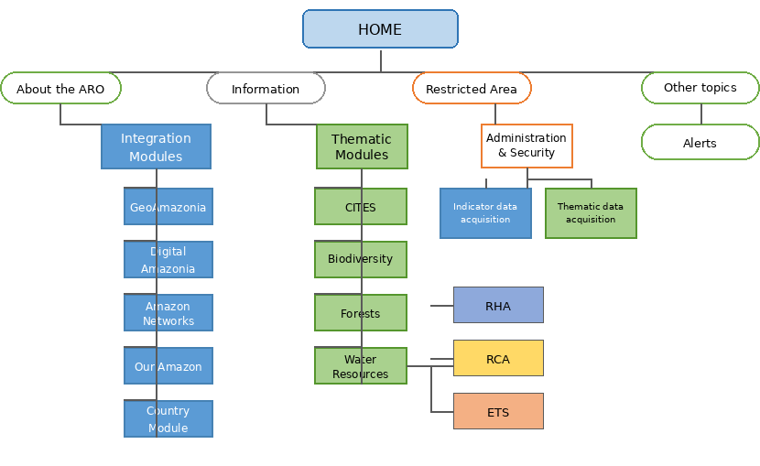
Figure 1. ARO organizational chart highlighting the elements of the Water Resources thematic module within which the Integrated IWRM Platform should be incorporated
    - Conceptual Framework of the Integrated IWRM Platform
The proposed macro-process for the Integrated IWRM Platform comprises seven processes and a set of products to be generated within a unified regional scenario-building framework. The seven processes are:
- Process for monitoring laboratory intercalibration procedures;
- Process for monitoring water-quality monitoring activities;
- Process for monitoring water-quantity monitoring activities;
- Process for monitoring ETS activities;
- Process for managing regional data and information;
- Process for monitoring pilot intervention projects;
- Education, Communication and Social Participation Process. These processes will be carried out under the supervision of a Technical Monitoring Group composed of technical members designated by the ACTO Member Countries, as well as members of ACTO's own technical staff.
The products of the Integrated IWRM Platform are important for providing the technical support required for decision-making. They are based on three pillars:
- Calculation of water balances and specific indices;
- Operational functioning of the monitoring system (ARO);
- Training and data- and information-sharing meetings.
The results of these pillars will be incorporated into the products of subsequent activities, particularly the preparation of the Regional Models and Scenarios Report. In addition, the outputs of pilot intervention projects will support prospects for new implementation measures and/or investments in actions consistent with regional needs or designed to address the specific characteristics of areas considered priorities, from both geographic and thematic perspectives.
In practical terms, a set of nine (9) reports must be generated at the end of each process cycle, as follows:
- Laboratory validation and certification report;
- Water-quality variability and mass-balance report (QA);
- Supply vs. Demand reports and reference values for P (rainfall) and Q (streamflow);
- ETS reports (Erosion, Transport and Sediment Deposition) using data obtained both in situ and by satellite, together with the corresponding calculation of QS (solid discharge);
- Processed-data reports - data received, processed and made available - as well as reports on user access to those data;
- Report on the operation of monitoring activities (situation rooms);
- Diagnostic reports (indices) for the Integrated IWRM Platform, based on information collected during seminars/training activities and on existing socioeconomic demands;
- Pilot-project status reports;
- IWRM reports using TWAP and/or SDG 6 indices.
Each report should follow an approach that presents a diagnosis of the current situation, an analysis of the situation in relation to reference operational protocols or a reference time frame, and an indication of a progress index based on quantifiable targets. It should also identify potential improvements so that new targets proposed within the scope of the same indicators assessed can be achieved.

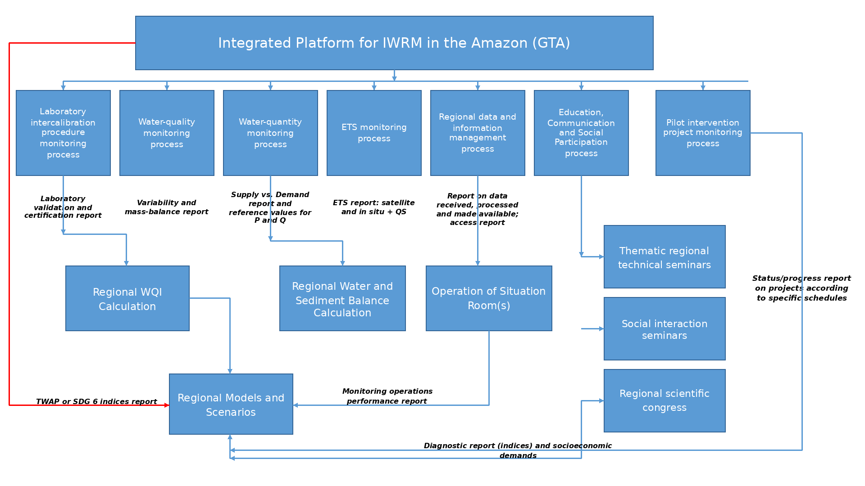
Figure 2. Organizational chart of the Integrated IWRM Platform, emphasizing products and decision-support inputs

Objectives and Activities of the Consultancy

3.1 General Objective

Provide continuous technical, operational, analytical and documentary support to the Project Coordination and the Senior Monitoring Specialist / Component 3, contributing to the advancement of activities related to the implementation of the Integrated Regional Information Platform for IWRM in the Amazon Basin through the preparation and preliminary review of documents, reports, technical notes, agendas and other technical inputs, which will be submitted for review, quality control and validation by the Senior Monitoring Specialist and the Project Regional Coordination Unit.

3.1 Main Activities
- Follow up and support the operation of the interoperability roundtables and the activities of the technical monitoring group in preparation for the implementation of the Integrated IWRM Platform, including activities between the ARO and GEODATIN that involve Project activities.
- Support the planning, thematic technical preparation, delivery, synthesis and reporting of training events related to the implementation of the Integrated IWRM Platform, including participation in meetings and technical discussions and the preparation of technical documents, concept notes and agendas.
- Support the follow-up of implementation and the strengthening of the use of national situation rooms and multiparameter equipment within the Integrated IWRM Platform, including the preparation of technical equipment specifications, follow-up of the procurement of field equipment, and support for the operational functioning of the rooms themselves.
- Support the senior consultant and the coordination team of the Amazon Basin Project - SAP/ACTO in the specialized technical supervision of national consultants and companies contracted to implement the Integrated IWRM Platform for monitoring water quantity and quality and the ETS Monitoring Programme, including reviewing reports, issuing technical assessments and participating in meetings.
- Other activities related to the implementation of the IP/IWRM assigned by the Project's Regional Coordination Office.

Products
A. Regarding the interoperability roundtables and the inputs generated for GEODATIN.
- Aides-mémoire for each interoperability meeting.
- Document systematizing and comparatively analysing the information provided by the countries within the interoperability process.
- Schedule of periodic coordination and follow-up meetings with national consultants to guide progress by the interoperability roundtables and the operation of interoperability, including activities with GEODATIN.
- Aides-mémoire containing the conclusions of bilateral meetings supporting consultants and national institutions in achieving interoperability.
- Technical assessments and guidance on GEODATIN activities aimed at achieving the IWRM Platform.
B. Regarding the development of the IWRM Platform and the ETS Programme.
- Schedule of periodic coordination and follow-up meetings with national consultants and contracted companies for the purposes of the Platform and the ETS Programme.
- Aides-mémoire containing the conclusions of bilateral meetings with both national consultants and companies.
- Monthly technical assessment of the technical coherence between the work of the national consultants and that of the company responsible for implementing the IWRM Platform and the ETS Programme.
C. Regarding training courses linked to the IWRM Platform and the ETS Programme.
- Preparatory documents - information documents, materials and agendas - follow-up and support for event dynamics, and consolidation of results - event records and technical reports - for training processes linked to the Integrated IWRM Platform and ETS.
- Based on the results obtained through the training activities, prepare technical reports on their linkage with regional products and with the companies advancing the IWRM Platform and the ETS Programme.
D. Regarding the strengthening and operation of the Situation Rooms, the ARO and regional products.
- Reports on the implementation process and start-up of the situation rooms, as well as on equipment acquired in each country in connection with monitoring and the operation of the rooms.
- Schedule of activities to support the ARO, with a view to the operation of the IWRM Platform and the ETS Programme.
- Two StoryMaps on the regional Source-to-Sea and Mercury Atlas products.
E. Regarding support for national consultants and regional companies
- Synthesis and comparative analysis document covering the different products of the national consultants and their linkage with regional products.
- Analysis and recommendations document to guide the work of the regional consultancies.

Qualifications, Requirements and Professional Experience
  - Qualifications - Academic Background
A completed university degree in Earth Sciences, Natural Sciences, Environmental Sciences or related fields relevant to the objectives of this consultancy. A master's degree and/or doctorate in a field related to the objectives of these Terms of Reference is desirable, particularly in water resources management.
  - Requirements
    - Experience in water resources management;
    - Good command of software and office suites (e.g. MS Office), particularly spreadsheets and word-processing applications;
    - Familiarity with developing work plans and managing their implementation;
    - Ability to use project-management and information-management tools;
    - Experience/knowledge in geoprocessing, particularly the use of ArcGIS;
    - Experience in developing StoryMaps;
    - Ability to work as part of a team and communicate in at least two ACTO languages;
    - Openness to a multicultural and multilingual environment; knowledge of, and good institutional/sectoral relations for, interaction between local institutions and regional technical coordination in the country of origin/interaction.
- Professional Experience
  - More than five years of demonstrated professional experience in water resources monitoring and management, of which at least two years in the Amazon region is desirable;
  - Experience in technical and/or scientific cooperation projects, particularly international projects.
- Contract Duration
The candidate will enter into a 12-month contract with the PS/ACTO. The consultancy will be performed in person at ACTO premises in Brasília at least two days per week.

Payment Conditions
Payments will be made every two months, subject to the delivery and approval of the reports on the products indicated above and under a results-based management modality, focusing on monitoring progress and structured technical assessments. The total value of the consultancy is USD 24,000.00.
The fees include insurance, taxes, and expenses related to travel, relocation, installation and residence at the duty station.
The consultant must issue an invoice or proof of payment in favor of the Amazon Cooperation Treaty Organization for each established disbursement. Payment will be made by bank transfer in national currency.

9. Supervision and Follow-up
The consultancy will be supervised by the PS/ACTO/RCU and the Senior Monitoring Specialist for Component 3.

